Group 4’s Model Use Case Diagrams ADAV System Final Report

Behavioral Report – Use Cases

Authors: Men at Work: Maxwell Polley, Ryan Patton, Josph Mitchell, Bill Symolon

|  |  |
| --- | --- |
| No Magic |  |
| One Allen Center, 700 Central Expressway South, Suite 110 Allen, Texas 75013 USA | Date: May 03, 2020 |

**Revision History**

|  |  |  |  |
| --- | --- | --- | --- |
| **Revision** | **Date** | **Reason For Changes** | **Author** |
| 0.1 | 05/03/2020 | Initial Draft | Men at Work |

**Table of Contents**

Introduction 1

Purpose 1

Scope 1

Overview 1

ADAV System::Behavioral Diagrams::Use Cases 2

Conduct Mechanic-Level (Unit Internal) Checks, Services, and Repairs 2

Configure ADAV for Maintenance 3

Deploy ADAV 4

Deploy Soldiers into Combat Zone 5

Load Crew 6

Load onto Vehicle, Transit Inland 7

Move to Shore While Under Attack 8

Neutralize Threats 9

Perform Operations in Transit 10

Pick Up Soldiers 11

Prepare ADAV 12

Protect Occupants from Enemy 13

Rearm the ADAV 14

Refuel ADAV 15

Remain on Station 16

Return to Ship for Extraction 17

Return to Training Start Location 18

Return Vehicle to Operational Configuration 19

Scenario 1 20

Scenario 2 21

Scenario 3 22

Scenario 4 23

Scenario 5 24

Scenario 6 25

Scenario 7 26

Takeoff, Transit, and Land 27

Transit from Water to Land 28

Transit Inland to Combat Zone 29

Unload from Transport 30

**Table of Figures**

Figure 1. Conduct Mechanic-Level (Unit Internal) Checks, Services, and Repairs 2

Figure 2. Configure ADAV for Maintenance 3

Figure 3. Deploy ADAV 4

Figure 4. Deploy Soldiers into Combat Zone 5

Figure 5. Load Crew 6

Figure 6. Load onto Vehicle, Transit Inland 7

Figure 7. Move to Shore While Under Attack 8

Figure 8. Neutralize Threats 9

Figure 9. Perform Operations in Transit 10

Figure 10. Pick Up Soldiers 11

Figure 11. Prepare ADAV 12

Figure 12. Protect Occupants from Enemy 13

Figure 13. Rearm the ADAV 14

Figure 14. Refuel ADAV 15

Figure 15. Remain on Station 16

Figure 16. Return to Ship for Extraction 17

Figure 17. Return to Training Start Location 18

Figure 18. Return Vehicle to Operational Configuration 19

Figure 19. Scenario 1 20

Figure 20. Scenario 2 21

Figure 21. Scenario 3 22

Figure 22. Scenario 4 23

Figure 23. Scenario 5 24

Figure 24. Scenario 6 25

Figure 25. Scenario 7 26

Figure 26. Takeoff, Transit, and Land 27

Figure 27. Transit from Water to Land 28

Figure 28. Transit Inland to Combat Zone 29

Figure 29. Unload from Transport 30

# 

# Introduction

## Purpose

This document provides an overview of the use case diagrams associated with the ADAV model.

## Scope

The Air Deliverable Amphibious Vehicle (ADAV) advances military personnel capabilities around rivers, estuaries, and littoral environments. The use case diagrams presented within detail the uses undertaken by the ADAV within its operational scenarios.

## Overview

This document presents 29 use case diagrams. The use case diagrams overview the 7 scenarios detailed in the Project Proposal and present them in a manner conducive to a deeper understanding of the ADAV’s operational uses.

# ADAV System::Behavioral Diagrams::Use Cases

## Conduct Mechanic-Level (Unit Internal) Checks, Services, and Repairs

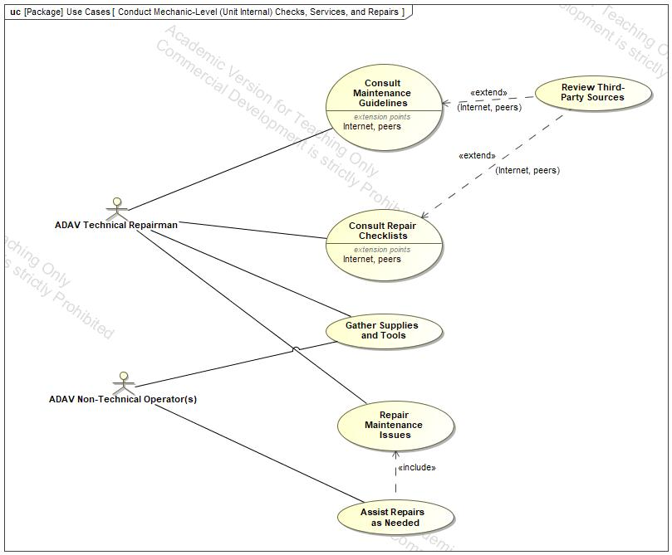

1. Conduct Mechanic-Level (Unit Internal) Checks, Services, and Repairs

## Description

The Conduct Mechanic-Level (Unit Internal) Checks, Services, and Repairs use case diagram seen in Figure 1 shows the uses by which the ADAV is maintained.

## Configure ADAV for Maintenance

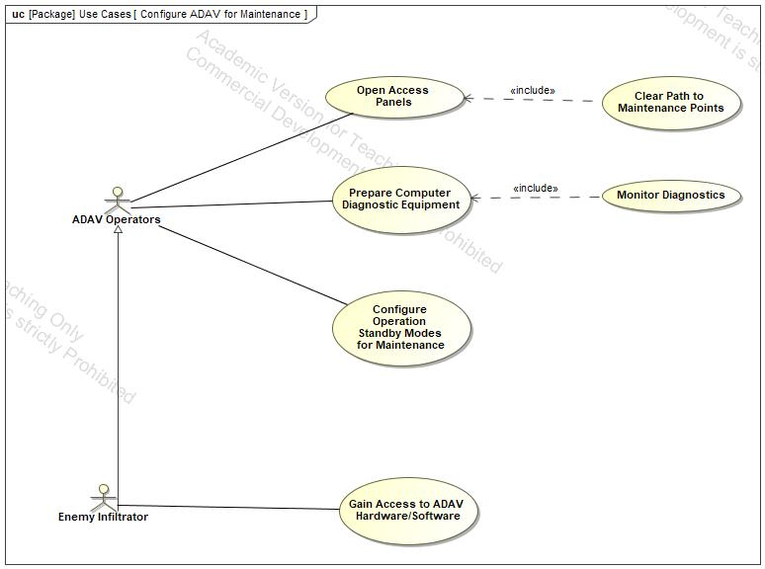

1. Configure ADAV for Maintenance

## Description

The Configure ADAV for Maintenance use case diagram seen in Figure 2 shows the uses by which the ADAV is prepared for maintenance.

## Deploy ADAV

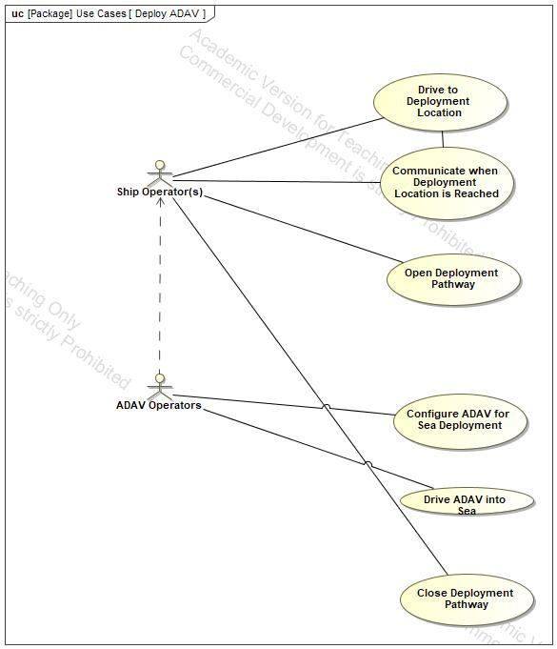

1. Deploy ADAV

## Description

The Deploy ADAV use case diagram seen in Figure 3 shows the uses by which the ADAV deploys from its associated vehicles.

## Deploy Soldiers into Combat Zone

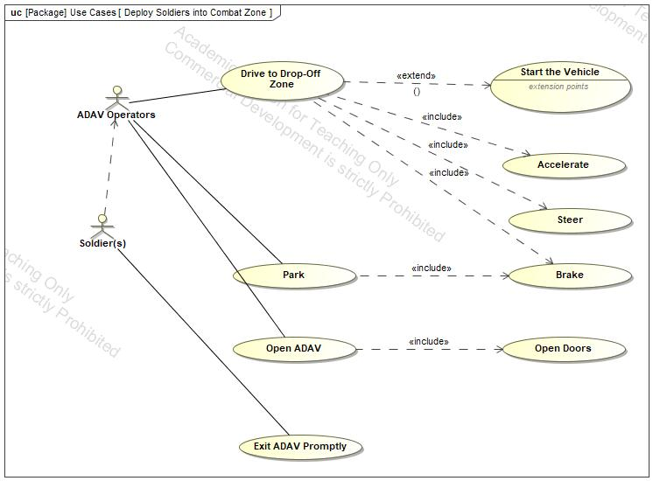

1. Deploy Soldiers into Combat Zone

## Description

The Deploy Soldiers into Combat Zone use case diagram seen in Figure 4 shows the uses by which the ADAV operators support soldiers’ deployment into combat zones.

## Load Crew

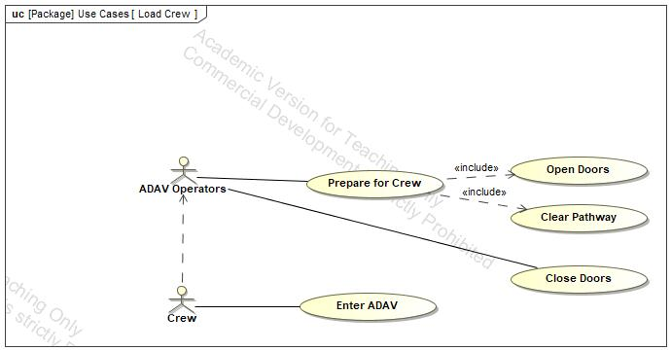

1. Load Crew

## Description

The Load Crew use case diagram seen in Figure 5 shows the uses by which the ADAV operators support the crew entering the ADAV.

## Load onto Vehicle, Transit Inland

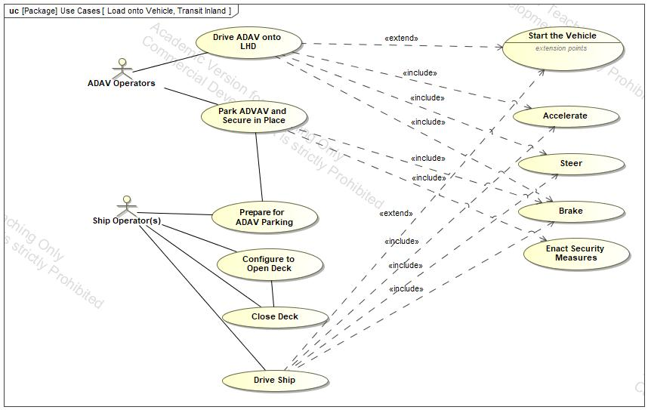

1. Load onto Vehicle, Transit Inland

## Description

The Load onto Vehicle, Transit Inland use case diagram seen in Figure 6 shows the uses by which the ADAV operators and ship operators work together to load the ADAV and prepare the ADAV during transit from sea to land.

## Move to Shore While Under Attack

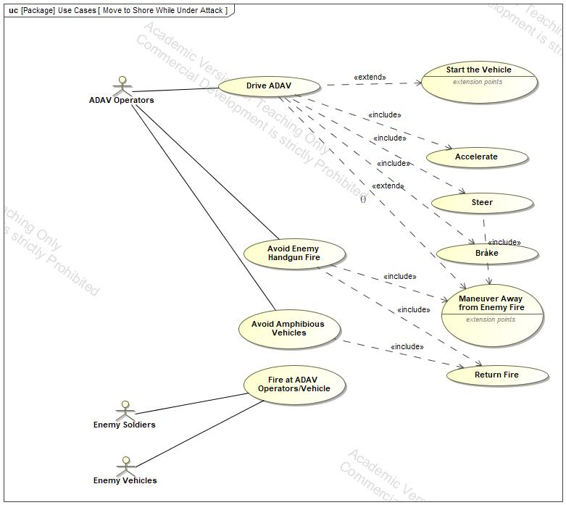

1. Move to Shore While Under Attack

## Description

The Move to Shore While Under Attack use case diagram seen in Figure 7 shows the uses by which the ADAV operator guides the ADAV away from enemy soldiers and vehicles.

## Neutralize Threats

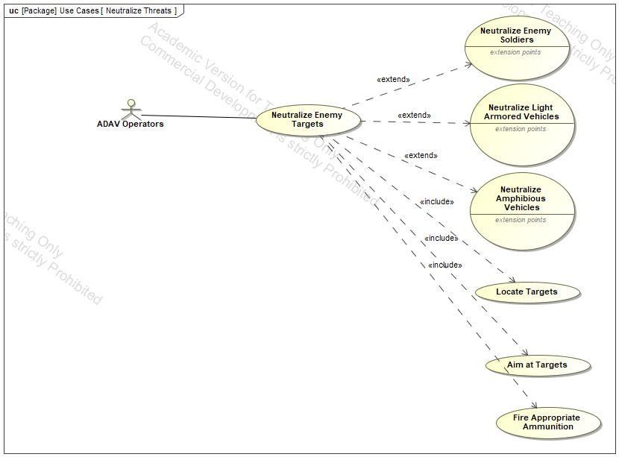

1. Neutralize Threats

## Description

The Neutralize Threats use case diagram seen in Figure 8 shows the uses by which the ADAV operators return lethal fire on enemy target(s).

## Perform Operations in Transit

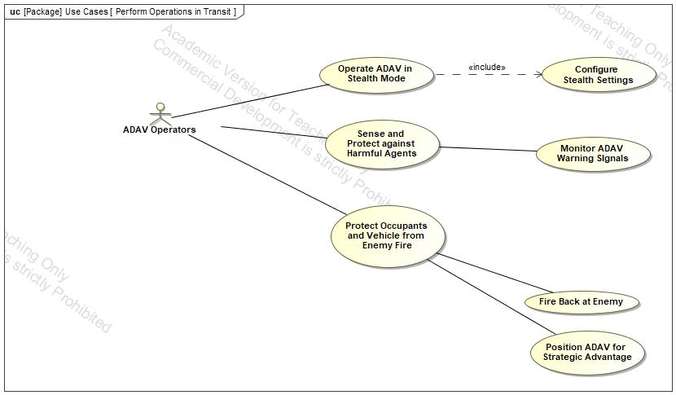

1. Perform Operations in Transit

## Description

The Perform Operations in Transit use case diagram seen in Figure 9 shows the uses by which the ADAV operators perform battlefield operations from the ADAV in combat zones.

## Pick Up Soldiers

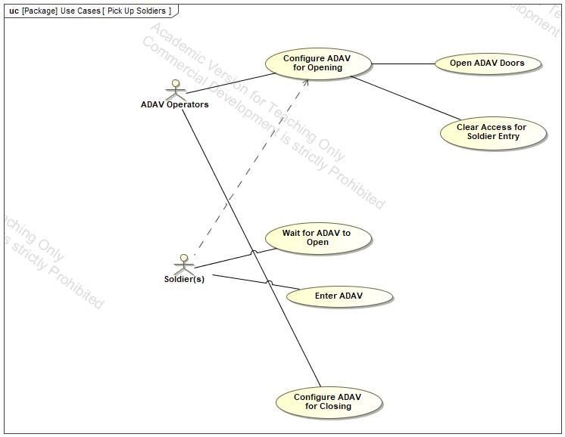

1. Pick Up Soldiers

## Description

The Pick Up Soldiers use case diagram seen in Figure 10 shows the uses by which the ADAV operators configure the ADAV to pick up soldiers in combat zones.

## Prepare ADAV

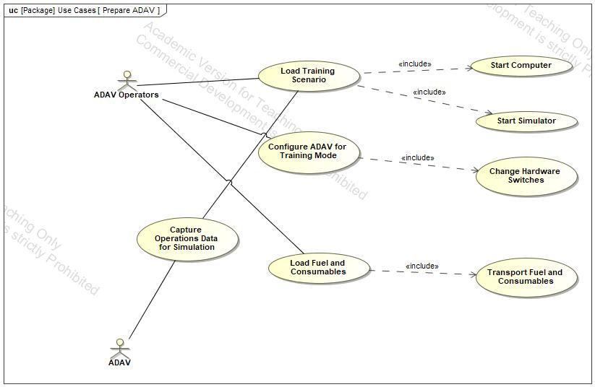

1. Prepare ADAV

## Description

The Prepare ADAV use case diagram seen in Figure 11 shows the uses by which the ADAV operators take proper measures to prepare ADAV in a simulated combat environment.

## Protect Occupants from Enemy

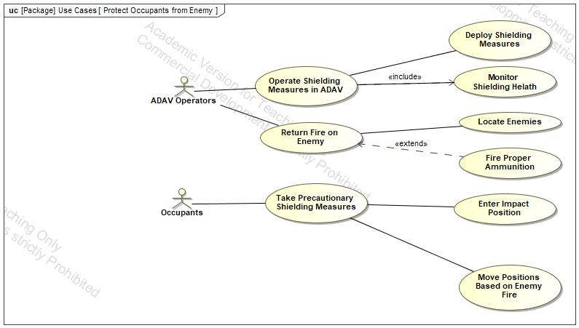

1. Protect Occupants from Enemy

## Description

The Protect Occupants from Enemy use case diagram seen in Figure 12 shows the uses by which the ADAV operators actively protect the vehicle’s occupants from enemy attacks.

## Rearm the ADAV

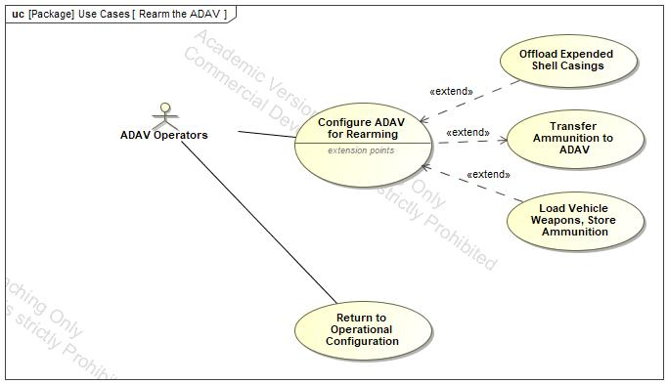

1. Rearm the ADAV

## Description

The Rearm the ADAV use case diagram seen in Figure 13 shows the uses by which the ADAV operators follow processes to rearm the ADAV.

## Refuel ADAV

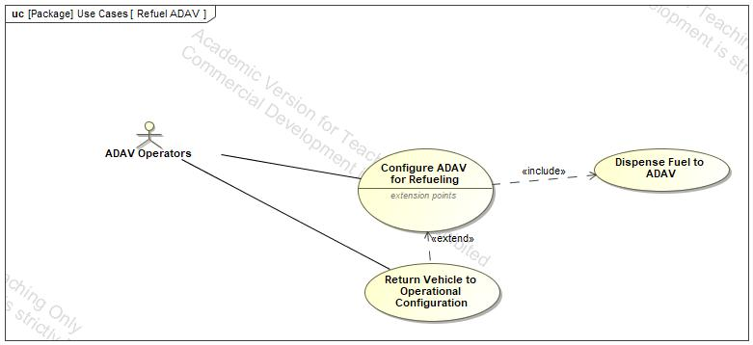

1. Refuel ADAV

## Description

The Refuel ADAV use case diagram seen in Figure 14 shows the uses by which the ADAV operators follow processes to refuel the ADAV.

## Remain on Station

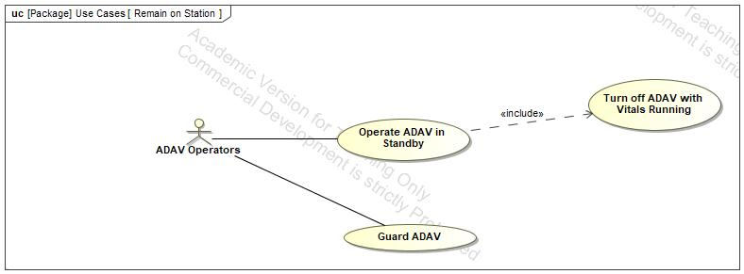

1. Remain on Station

## Description

The Remain on Station use case diagram seen in Figure 15 shows the uses the ADAV operators perform during standby mode on base.

## Return to Ship for Extraction

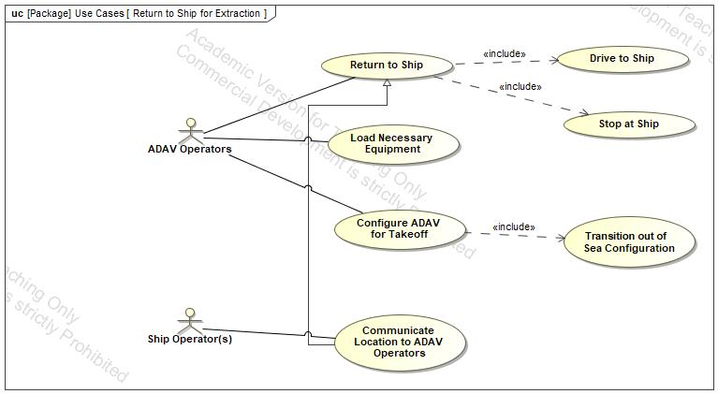

1. Return to Ship for Extraction

## Description

The Return to Ship for Extraction use case diagram seen in Figure 16 shows the uses by which the ADAV operators work with the ship operators to facilitate the return and loading of the ADAV after missions.

## Return to Training Start Location

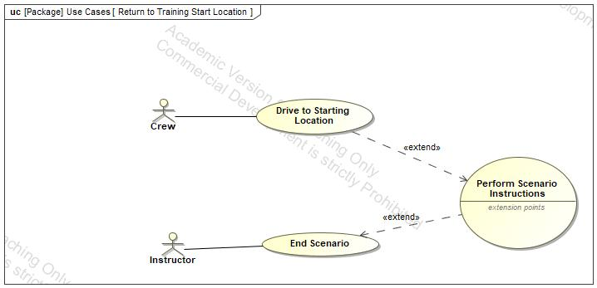

1. Return to Training Start Location

## Description

The Return to Training Start Location use case diagram seen in Figure 17 shows the uses by which the ADAV crew returns in a simulated environment to the training start location.

## Return Vehicle to Operational Configuration

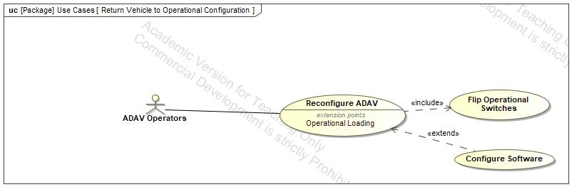

1. Return Vehicle to Operational Configuration

## Description

The Return Vehicle to Operational Configuration use case diagram seen in Figure 18 shows the uses by which the ADAV operators configure the ADAV to perform battlefield operations.

## Scenario 1

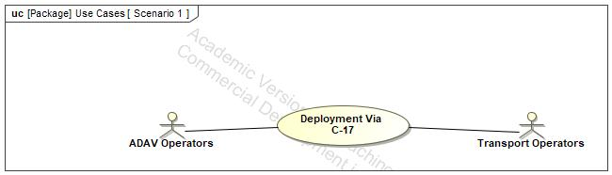

1. Scenario 1

## Description

The Scenario 1 use case diagram seen in Figure 19 shows the operational scenario and associated personnel before breaking down into its associated sub-use cases.

Details Scenario One – Deployment via C-17

The sub-use cases contained within the scenario use case consist of the following:

Prepare ADAV

Load onto Vehicle, Transit Inland

Unload from Transport

Protect Occupants from Enemy

Remain on Station

Neutralize Threats

Return to Ship for Extraction

## Scenario 2

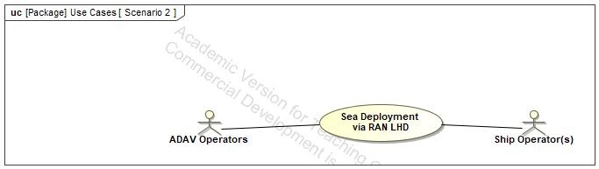

1. Scenario 2

## Description

The Scenario 2 use case diagram seen in Figure 20 shows the operational scenario and associated personnel before breaking down into its associated sub-use cases.

Details Scenario Two – Sea Deployment via RAN Landing Helicopter Deck (LHD)

The sub-use cases contained within the scenario use case consist of the following:

Prepare ADAV

Load onto Vehicle, Transit Inland

Move to Shore While Under Attack

Transit from Water to Land

Transit Inland to Combat Zone

Protect Occupants from Enemy

Remain on Station

Neutralize Threats

Return to Ship for Extraction

## Scenario 3

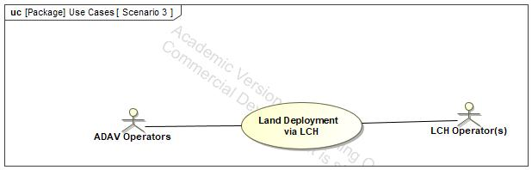

1. Scenario 3

## Description

The Scenario 3 use case diagram seen in Figure 21 shows the operational scenario and associated personnel before breaking down into its associated sub-use cases.

Details Scenario Three – Land Deployment via Landing Craft Heavy (LCH)

The sub-use cases contained within the scenario use case consist of the following:

Prepare ADAV

Load onto Vehicle, Transit Inland

Deploy ADAV

Transit Inland to Combat Zone

Protect Occupants from Enemy

Remain on Station

Neutralize Threats

Return to Ship for Extraction

## Scenario 4

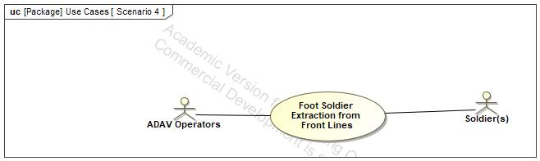

1. Scenario 4

## Description

The Scenario 4 use case diagram seen in Figure 22 shows the operational scenario and associated personnel before breaking down into its associated sub-use cases.

The sub-use cases contained within the scenario use case consist of the following:

Prepare ADAV

Load onto Vehicle, Transit Inland

Deploy ADAV

Transit from Water to Land

Transit Inland to Combat Zone

Perform Operations in Transit

Pick Up Soldiers

Return to Ship for Extraction

## Scenario 5

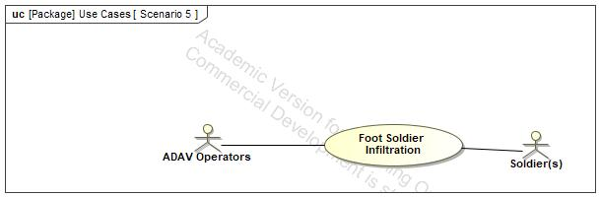

1. Scenario 5

## Description

The Scenario 5 use case diagram seen in Figure 23 shows the operational scenario and associated personnel before breaking down into its associated sub-use cases.

Details Scenario Five – Foot-Soldier Infiltration

The sub-use cases contained within the scenario use case consist of the following:

Prepare ADAV

Load onto Vehicle, Transit Inland

Move to Shore While Under Attack

Transit from Water to Land

Perform Operations in Transit

Deploy Soldiers into Combat Zone

Remain on Station

Neutralize Threats

Pick Up Soldiers

Return to Ship for Extraction

## Scenario 6

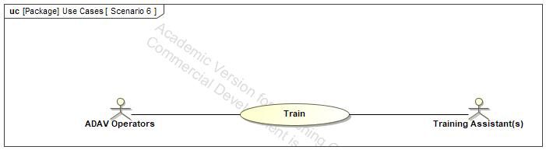

1. Scenario 6

## Description

The Scenario 6 use case diagram seen in Figure 24 shows the operational scenario and associated personnel before breaking down into its associated sub-use cases.

Details Scenario 6 – Training

The sub-use cases contained within the scenario use case consist of the following:

Prepare ADAV

Load Crew

Transit Inland to Combat Zone

Protect Occupants from Enemy

Remain on Station

Neutralize Threats

Return to Training Start Location

## Scenario 7

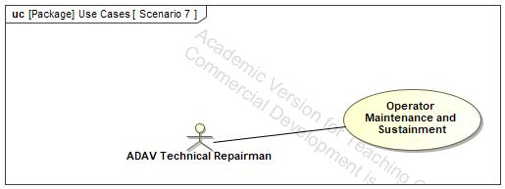

1. Scenario 7

## Description

The Scenario 7 use case diagram seen in Figure 25 shows the operational scenario and associated personnel before breaking down into its associated sub-use cases.

Details Scenario Seven – Operator Maintenance and Sustainment

The sub-use cases contained within the scenario use case consist of the following (from top to bottom):

Configure ADAV for Maintenance

Conduct Mechanic-Level (Unit Internal) Checks, Services, and Repairs

Return Vehicle to Operational Configuration

Refuel ADAV

Rearm the ADAV

## Takeoff, Transit, and Land

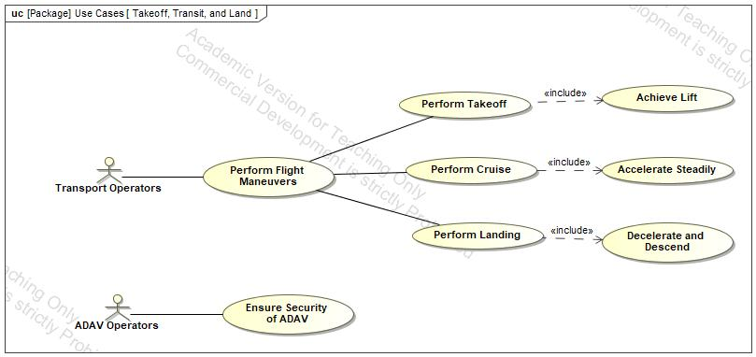

1. Takeoff, Transit, and Land

## Description

The Takeoff, Transit, and Land use case diagram seen in Figure 26 shows the uses by which the ADAV operators and transport operators support transportation to battlefield proximity.

## Transit from Water to Land

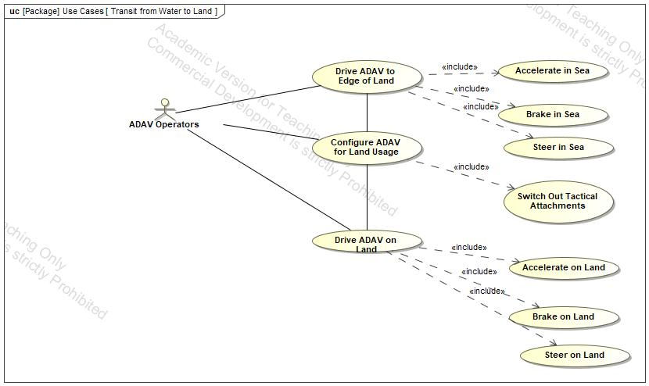

1. Transit from Water to Land

## Description

The Transit from Water to Land use case diagram seen in Figure 27 shows the uses by which the ADAV operator performs operations to drive the ADAV from its starting sea location to land.

## Transit Inland to Combat Zone

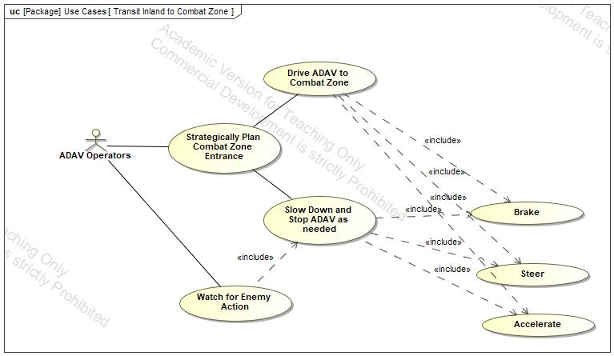

1. Transit Inland to Combat Zone

## Description

The Transit Inland to Combat Zone use case diagram seen in Figure 28 shows the uses by which the ADAV operators drive the ADAV from the edge of sea to the inland combat zone.

## Unload from Transport

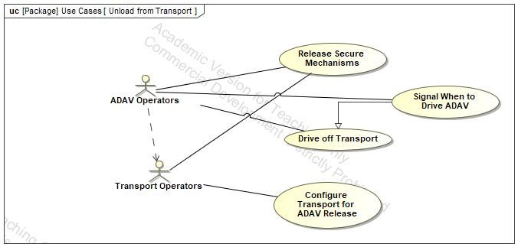

1. Unload from Transport

## Description

The Unload from Transport use case diagram seen in Figure 29 shows the uses by which the ADAV operators work with transport operators to facilitate unloading the ADAV.